# **CSE-2004 DBMS J-Component**

**Name: Dhairya Ostwal Reg. No: 19BCE2199**

**INSTRUCTOR: Dr. Anand Bihari DATE: 26 July 2020**

**TOPIC:** E-Pharmacy Database Management System

## **ABSTRACT:**

India being a highly vast market for innovation and several products but several studies still show that only 1% pharmacy stores have opted for online mode of doing business.

(Ref: thepassage.cc article 748)

But seeing today’s era of COVID-19 and continuous lockdown there is an immediate requirement for pharmacy shops to switch to online mode of conducting business. With several telecom & technological players providing affordable data packs and smartphones India since 2014 has seen rise in the use of smartphones in all demographic locations if the country.

Hence this project focusses on database schema and database creation for helping small pharmacy shops transition to online mode of conducting business and hereby expand their customer base with the large customers being available online.

## **KEYWORDS:**

Pharmacy, Online shop, E-Retail, E-Pharmacy, Medicine, Ecommerce, COVID-19

## **IMPLEMENTATION & EXPECTATIONS OF THE PROJECT:**

1. Creating Table
2. Inserting Data into table
3. Performing several basic queries, PL/SQL functions, Trigger functions

## **TECHNOLOGY STACK USED:**

Oracle SQL Server

## **E-R Diagram:**

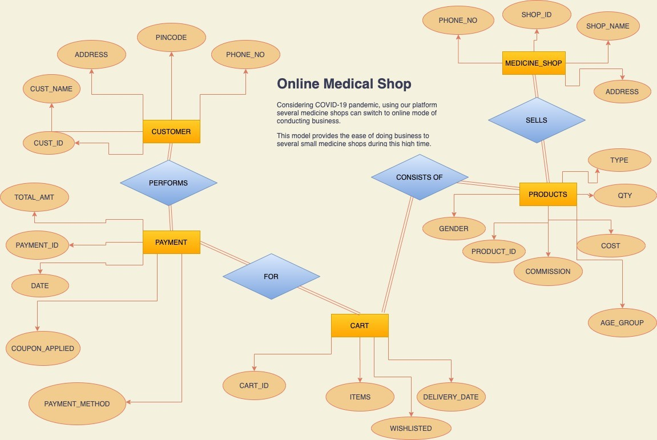

**Relational Database Schema:**

